Exercise 3: SQL CASE Statements
Nandipha Dondashe
Data Analytics
BrightLearn
08 September 2026
2805002580

- Classify each product by price into the three tiers below
'Expensive' if price > 1000,
'Mid-range' if price between 100 and 1000,
'Budget' if price < 100
(EXPECTED COLUMNS: product_name,price, price_category)

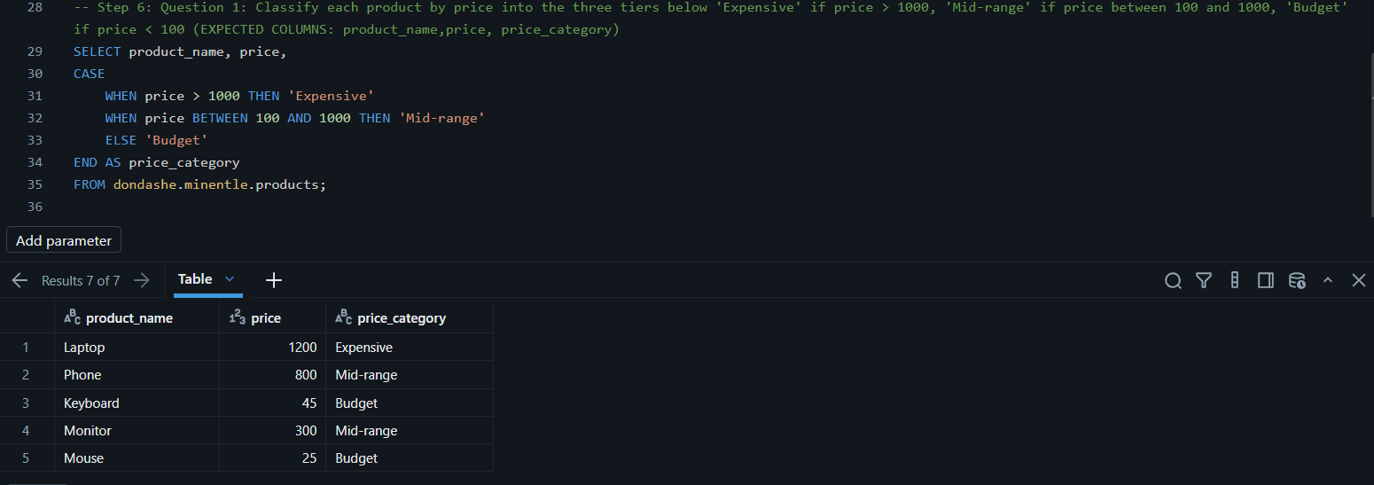

- Label each order by its value.
'High Value' for orders ≥ 1000
'Medium Value' for 500–999.99
'Low Value' for orders < 500 999.99 45.50 1200.00
(EXPECTED COLUMNS: customer_name amount order_value_category)

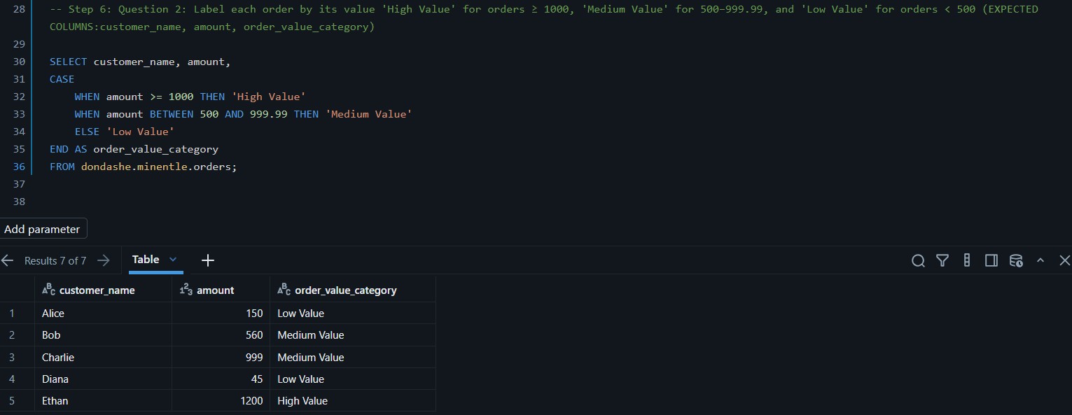

- Categorize each employee's position level using both department and salary.
If in 'IT' and salary > 80000 → 'Senior IT'
If in 'HR' and salary > 55000 → 'Experienced HR'
Otherwise → 'Staff' (EXPECTED COLUMNS: emp_name 04 The students Table department salary position_level)
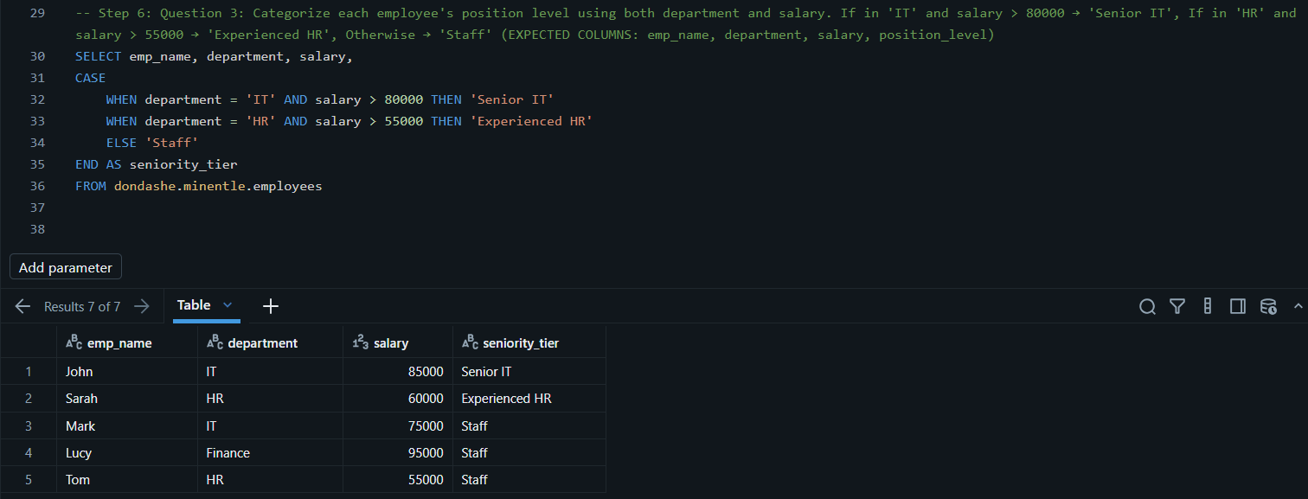

- Assign each student a letter grade based on their score.
≥ 90 → 'A'
80–89 → 'B'
70–79 → 'C'
60–69 → 'D'
< 60 → 'F' (EXPECTED COLUMNS: student_name, score, grad)
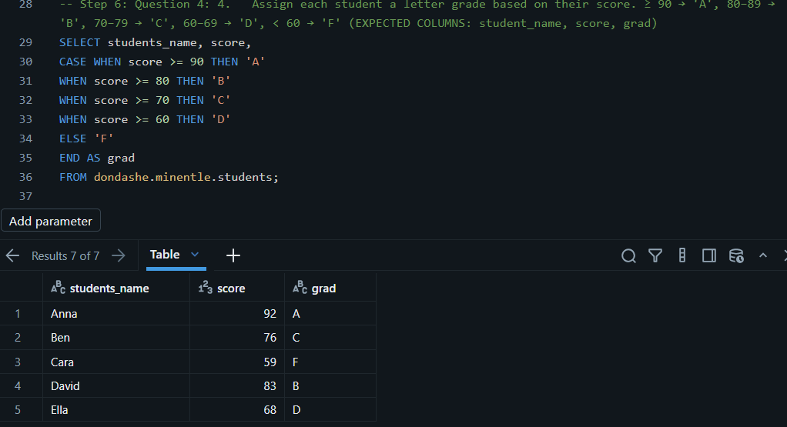

- Label delivery performance based on the time taken.
≤ 30 mins → 'Fast'
31–60 mins → 'On Time'
> 60 mins → 'Late'
(EXPECTED COLUMNS: delivery_id, delivery_time_minutes, performance)

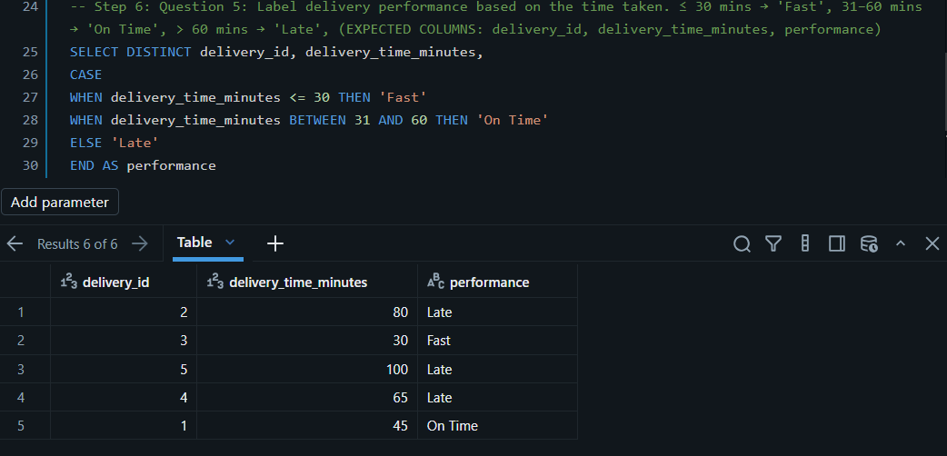

- Convert the numeric priority into a readable label.
3 → 'High'
2 → 'Medium'
1 → 'Low' 2
(EXPECTED COLUMNS: issue_type, priority, priority_label)

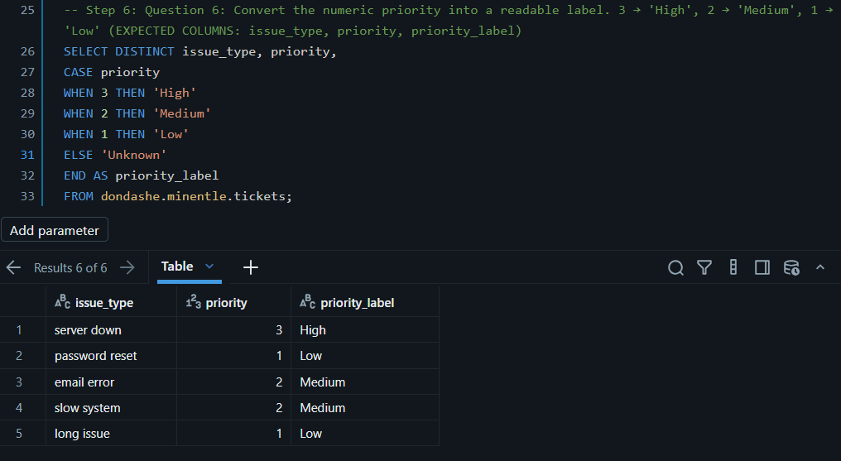

- Calculate attendance percentage and classify the result.
≥ 90% → 'Excellent'
75–89% → 'Good'
< 75% → 'Needs Improvement'
(EXPECTED COLUMNS: student_id, attendance_percentage, attendance_status)

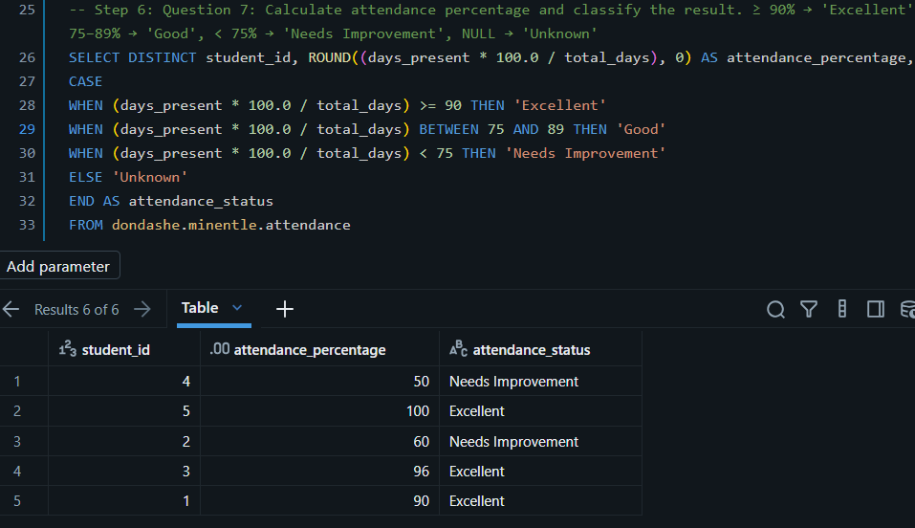

- Label the stock status of each product.
0 → 'Out of Stock'
1–5 → 'Low Stock'
> 5 → 'In Stock'
(EXPECTED COLUMNS: product_id, stock_qty, stock_status)

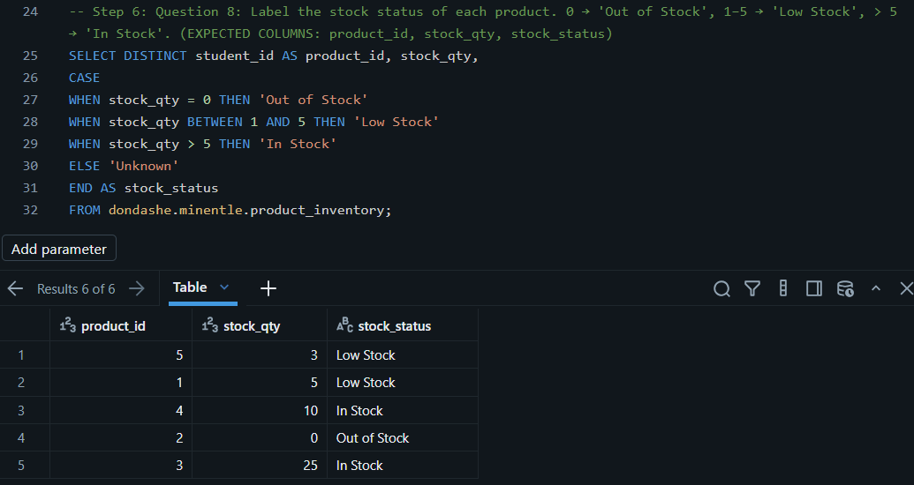

- Classify each class by the number of enrolled students.
≥ 25 → 'Large'
10–24 → 'Medium'
< 10 → 'Small'
(EXPECTED COLUMNS: subject, enrolled_students)

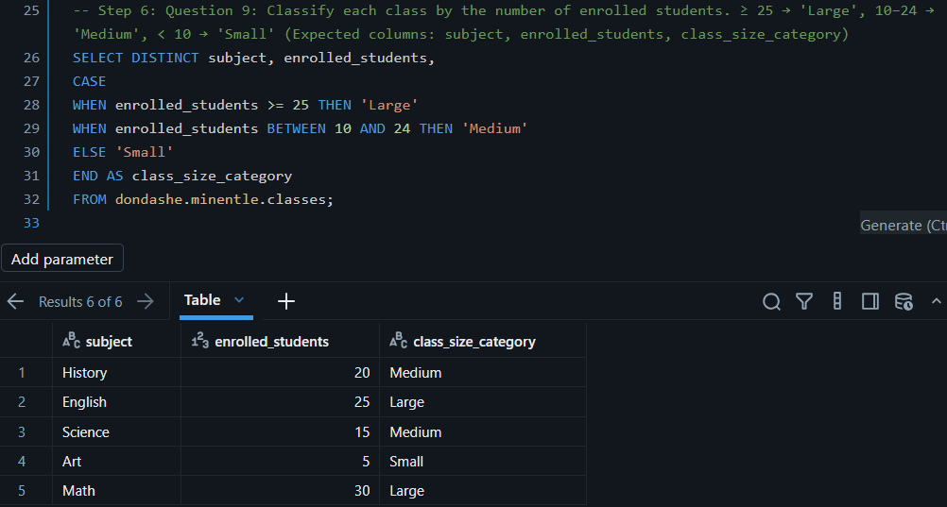

- Apply a discount flag based on the payment method and amount.
If payment_method = 'Cash' and amount ≥ 200 → 'Eligible for Discount' Otherwise → 'Not Eligible'
(EXPECTED COLUMNS: payment_id, payment_method, amount, discount_eligibility)
